How to add files and submit work

Step 1: Log in to Google Classroom as normal.
Step 2: Click on Classwork
Step 3: Choose the work you want to submit work for.
Step 4: Click on + Add or Create and choose file
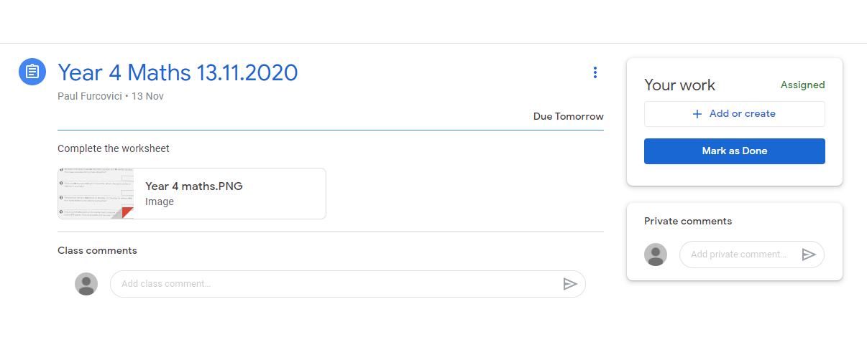
Step 5: Click on Upload and then Browse
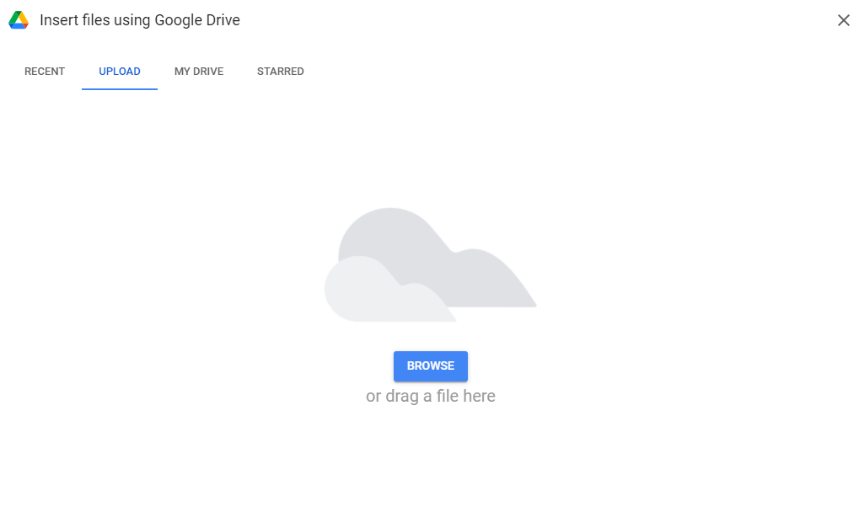

Step 6: Find your file and click open
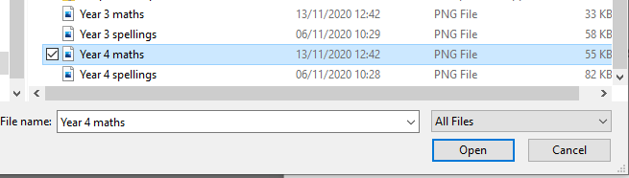
Step 7: Click hand in and then you are done
