The Very Hungry Caterpillar by Eric Carle - Comprehension
https://www.youtube.com/watch?v=75NQK-Sm1YY
Watch the animated version of The Very Hungry Caterpillar and discuss as you go along.
Read out the questions and scribe the answers.

- Listen to the music at the start of the story, think about…
- What time of day is it when the music starts?
- How does the music make you feel?
- What time of year is it? How do you know?

- What was on the leaf?

- How did the author describe the sun?
- What colour was the sun?
- What colours do I need to mix to make this colour?

- What day did the caterpillar pop out of the egg?
- How did the caterpillar feel?
- What do you think he was thinking when he came out?
- Imagine you are a little caterpillar and you have just popped out of your egg. Look around you, how do you think you would feel?
- Why do you think the music changes when the caterpillar goes off to look for his food?

- What day…
- Does he eat through the three plums?
- Does he eat through the five oranges?
- Does he eat through one apple?
- Does he eat two Pears

- On Thursday he ate through four strawberries, how did feel?
- How do you know?

- How many items did he eat on Saturday?
– Can you describe how the caterpillar would have felt just after eating the watermelon?
Imagine that you ate all that food, how do you think you would feel?

- What did he build around himself after eating the leaf?
- How long did he stay in his cocoon?
- How many days is that?

- Can you describe the music when the caterpillar came out as a butterfly?
_ What did you notice about the colours around him?
– How did the music and colours make you feel?

The Very Hungry Caterpillar by Eric Carle
Do not forget to show your working out, you can write a number sentence or use apparatus to work show your working out and answer.

- How many days are there in a week?
- Can you name them?

- On Monday, the caterpillar ate an apple, on Tuesday he ate two pears and on Wednesday he ate three plums. How many pieces of fruit did he eat altogether?

- How many pieces of fruit did he eat from Monday to Friday?
- How many pieces of fruit would he eat if the number is doubled?
- How many pieces of fruit would he eat if the number is halved?

- How many items of food did he eat on Saturday?
- Imagine he ate double the amount of food on Saturday, how many items of food would he have eaten?
- If he only ate half of the food he ate on Saturday, how many pieces of food would he have eaten?

- How many items of food did he eat over the week?

- If the caterpillar was 5cm long and he grew 6cm over the week. How long will he be? Think about what you can use to solve the problem. Think about what number sentence you need to write.

- If my leaf is 15cm long, how many Hungry Caterpillars could I get on it at the beginning of the week? Think about what you can use to solve the problem. Take photographs of your findings

- If I wanted to get three Hungry Caterpillars on a leaf, how long does the leaf need to be? Think about what you can use to solve the problem. Take photographs of your findings

- Draw a butterfly and make the pattern on it symmetrical.

- Draw or create your own Hungry caterpillar using different repeated patterns. Remember you can use things around the house, toys, Lego etc.

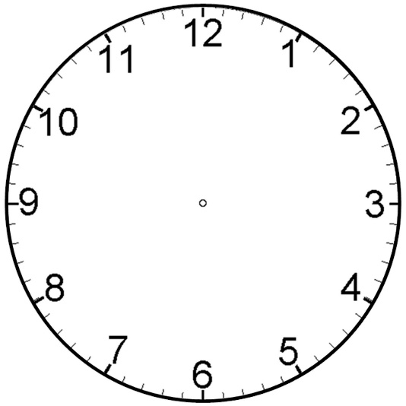
Snack at 7 o’clock
Go to the park at 3 o’clock
Tea at 5 o’clock
Lunch at 12 o’clock
Snack at 10 o’clock
Breakfast at 8 o’clock
Put the hands on the clock faces to tell the correct time.

Bedtime at Quarter To 7
Tea at Quarter Past 5
Lunch at Half Past 12
Snack at Half past 10
Breakfast at Half Past 8
Extension Task: Put the hands on the clock faces to tell the correct time.
Go to the park at Half Past 3

