Chenies Taekwon-do Club
Thursday – Spring term 2023
www.totaltkd.org
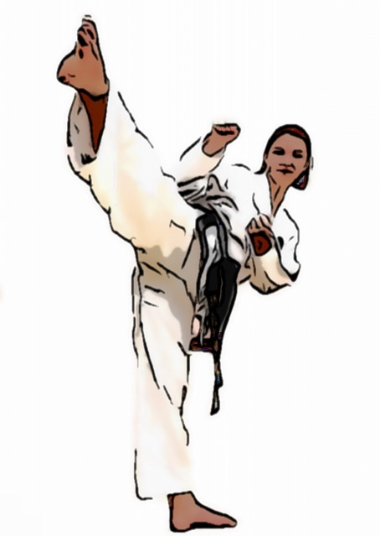
Dear Parents,
Welcome to Nick Symonds Taekwon-Do School. Classes will be taught every Thursday from 3.15pm – 4.15pm in the hall. The classes will be taught by Mr Jamie Ling 2nd degree black belt.
The classes are designed for all ages, with regular training the students can take their grading and work their way to black belt. Taekwon-do is a great form of exercise both physically and mentally. Classes focus on teaching all aspects of the art with the aim to develop well rounded martial artist.
Grading & Official uniforms
In the New Year we will be taking orders to purchase the official Taekwon-do uniforms and inviting students to attend their 1st grading.
Dates, costs & enrolment
The lessons will start on Thursday 12 January and end for the term on Thursday 30 March, the cost for the term for £82.50.
If you would like your child to enrol in the club then please send payment for the term and an email to nick@totaltkd.org notifying me of your child’s name, year, email and Contact number.The term fees should be sent to the following account, with your child’s name and school as reference.
Payments can be sent to.
K Symonds
Account – 50617261 Sort – 20-36-16
Regards,
Master Nick Symonds 7th degree

