How to log in on Google Classroom:

Step 1: Search Google Classroom on Google
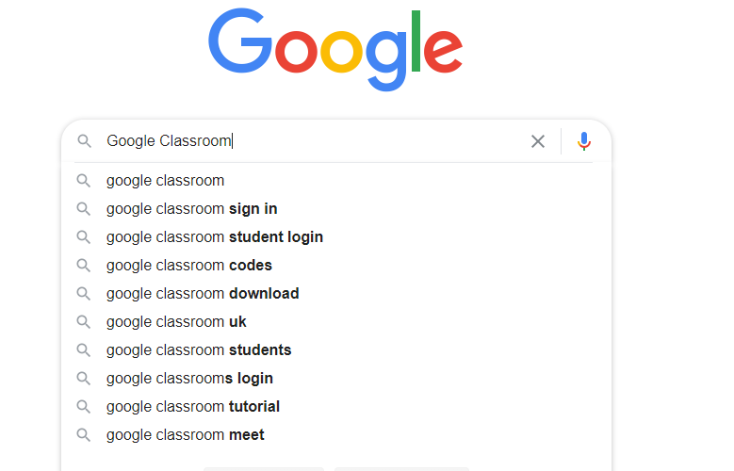
Step 2: Click on the search result that has “classroom.google.com” as its website (Alternatively, type www.classroom.google.com into your address bar and skip both these steps)
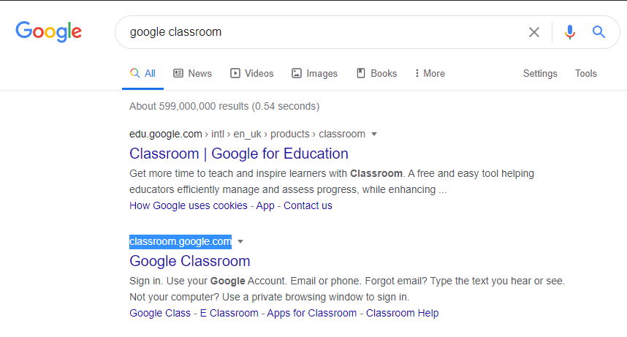
Step 3: Click on “Go to Classroom”
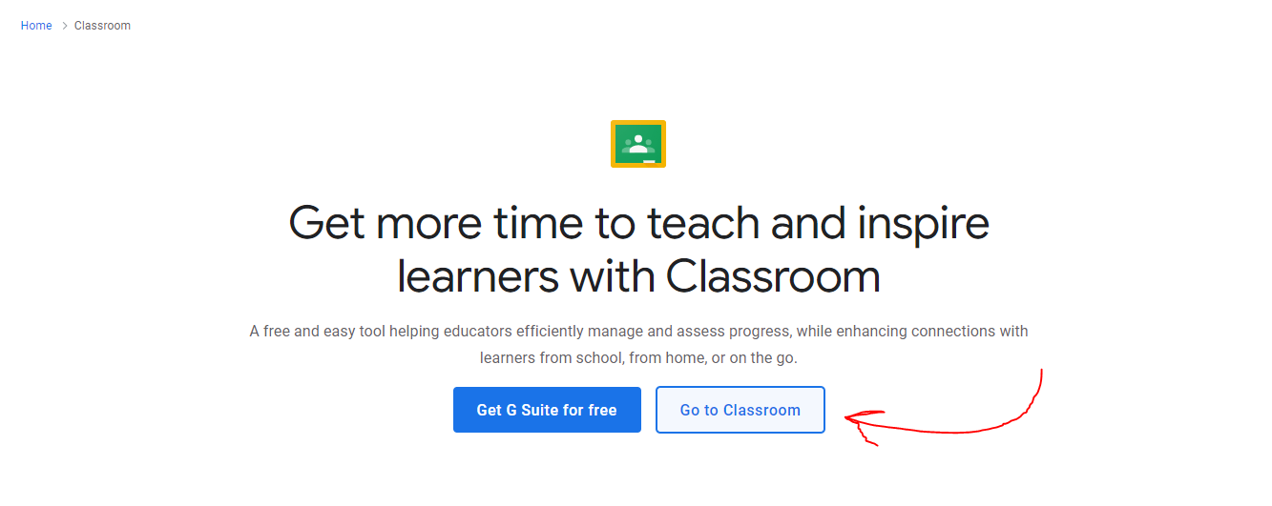
Step 4: Type in your child’s school email address. This is usually the first letter of their first name and their family name @chenies.bucks.sch.uk (e.g. mmcconaughey@chenies.bucks.sch). Then click next.
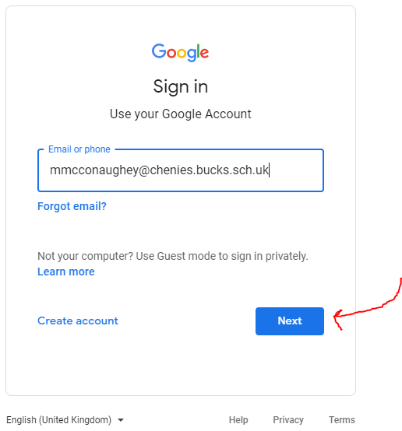
Step 5: Type in the password. Your child should know this and have it written down in their reading record book. If they forgot, no worry! Let us know and we can reset it, then they can write down their new one somewhere safe at home.
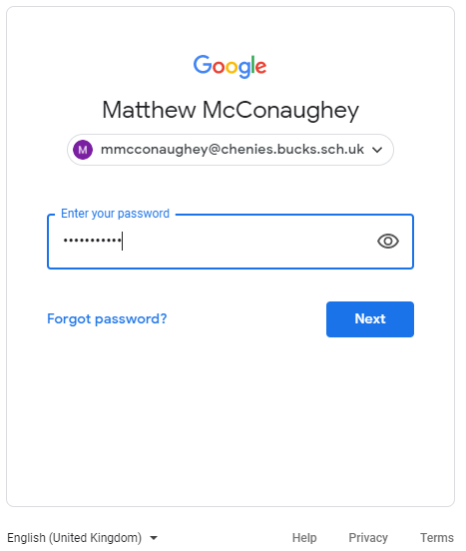

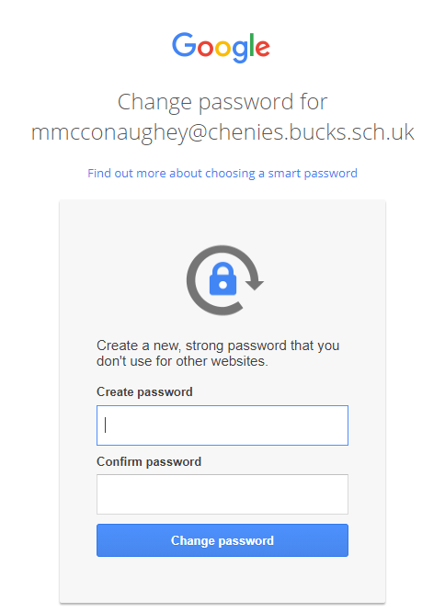
Step 5a: If you did reset your password, the window that will ask you to change it will look like this.

Step 6: Click on your child’s classroom
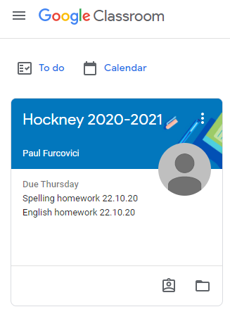
Step 7: At the top of the page you will have something like this
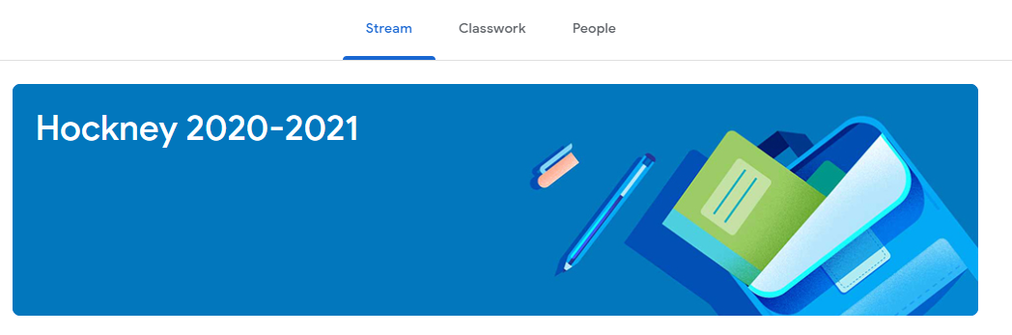
You will be mostly using the “Classwork” tab. Click on that and your child will be presented with a list of classwork set by the teacher to do, be this homework or lessons during a school lockdown or isolating.

