Three coins

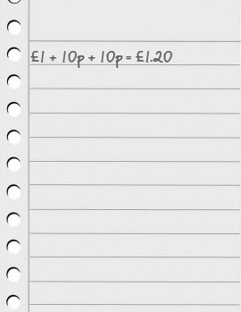
- Make an amount of money between £1 and £2 using exactly three coins. You can use a coin more than once.
- How many different amounts between £1 and £2 can be made using EXACTLY three coins?
- What is the smallest amount that you can make?
And the largest amount?

Can you be certain that you have them all?
Do you think you would be able to make more or fewer amounts between £3 and £4? Why?

